Centrality and cities
Multiple Centrality Assessment as a tool for urban analysis and design

Sergio Porta
Human Space Lab - Politecnico di Milano
sergio.porta@polimi.it

Vito Latora
Dipartimento di Fisica, Università di Catania
INFN Sezione di Catania
vito.latora@ct.infn.it

1. Introduction: centrality and cities

If you ask a grocer where he would locate his new shop you will probably see him mumbling a little bit in search of something. He is exploring his mental map of the city or the neighbourhood. Then he will come out pointing his finger on the map and saying: “yes, that’s the best location”. Why that? “You know – he will point out – here’s where all the people pass for going to work every morning, then here, at the corner between Massave and Pearl [I am picking up an example from Boston…], you are quite close to everywhere in the neighbourhood, then Massave is really a spine that everyone knows in the city for it is straight down to the river, then to the South End and downtown as well”. There is a lesson here about how a real city works which claims for the crucial importance of one factor, among many others, that we call “centrality”. Everyone knows that a place which is central has some special features to offer in many ways to those who live or work in cities: it is more visible, more accessible from the immediate surroundings as well as from far away, it is more popular in terms of people walking around and potential customers, it has a greater probability to develop as an urban landmark and a social catalyst or offer first level functions like theatres or office headquarters as well as a larger diversity of opportunities and goods. That’s why central locations are more expensive in terms of real estate values and tend to be socially selective: because such special features make them provide a reasonable trade off to larger investments than in less central spots of the same urban area.

If you look at where a city centre is located, you will mostly – if not always – find that it sprouts from the intersection of two main routes, where some special configuration of the terrain or some particular shape of the river system or the waterfront makes that place compulsory to pass through. That’s where cities begin. Then, departing from such central locations, they grow up in time adding here and there buildings and activities, firstly along the main routes, then filling the in-between areas, then adding streets that provide cyclic routes and points of return, then, as the structure becomes more complex, forming new central streets and places and keeping buildings around them again. It is an evolutionary process that has been driving the formation of our urban bodies, the heart of human civilization, through ages for the most of the seven millenniums of the city history until the dawn of modernity and the very beginning of the industrial age. Thus, we here understand that centrality is not just at work at the heart of contemporary urban life, linking spatial forms and collective behaviours, but is rather at the heart of the evolutionary process that made our cities what they have always been, with a strong impact on how they still are in our days.

At this point, the reader would have matured the idea that urban planners and designers have been spent the most of their time trying to understand and manage how centrality works in cities. Nothing could be less true. Despite the relevance of the issue, studies on centrality in cities have seldom been undertaken and never as a comprehensive approach to the subject. Geographers and transport planners have used centrality as a means to understand the location of uses and activities at the regional scale or the level of convenience to reach a place from all others in an urban system (Wilson, 2000): in so doing, they have built their understanding on some hidden assumptions, particularly on a notion of centrality that, putting it shortly, is limited to the following: the more a place is close to all others, the more central.

Since the early Eighties space syntax, a methodology of spatial analysis based on visibility and integration, opened to urban designers a whole range of opportunities to develop a deeper understanding of some structural properties of city spaces, but such opportunities have been seldom understood, often perceived as a quantitative threat to the creativity embedded in the art of city design. From a technical point of view, however, space syntax does not escape some of the shortcomings of regional analysis and transport planning: it is not a study of centrality in its own sake, it is mainly based on the same concept of being central as being close to all others, does not focus on the different geographies that different ways of being central actually “shape” on a city structure and how such different geographies correlate with the dynamics that take place in a city (like commercial location, real-estate values or information flows). However, recent developments from within the space syntax community seem to have acknowledged centrality and opened to a more diversified concept of spatial configuration in relation to approaches of social psychology and cognition. Space syntax apart, however, urban designers have in general simply skipped the problem: they basically deal with the aesthetics of the urban landscape and the components of the urban form that embed regulatory issues like the height of buildings or the f.a.r. (floor-area ratio). More recently, urban designers have investigated a whole range of new issues that address the question of the liveability of places under the great umbrella of urban sustainability: that’s where this paper actually come from.

In this paper we present a discussion of centrality in cities and a model, named Multiple Centrality Assessment (MCA) which helps in managing centrality for urban planning and design purposes. In so doing, we summarize a research that we have been undertaking for the last couple of years and is now being published in journal of urban planning and physics (Porta S et al, 2006a,b; Cardillo et al, 2006; Crucitti et al, 2006a,b; Scellato et al, 2006). In addition, we are hereby offering the first results of a new effort aimed at putting some light on how centrality, in its various forms, correlates to several dynamics of city life, a research which is actually still under way over larger cases and datasets.

2. Representing the city

Our research on centrality in cities is based on representing the structure of the city (which we identify as the system of city streets and their intersections) by means of a mathematical object called graph, which is a set of points, or nodes, linked by a set of lines, or edges. Graphs have been widely used for developing a deeper understanding of how complex systems of all sorts actually work. The property of a graph is in fact to focus on the relationships between individual components rather than the property of such components in themselves: in this sense, nodes might well represent components as different as co-authors in scientific systems (linked by co-authorships), routers in internet systems (linked by telephone cables), airports in air-communication systems (linked by air routes), or individuals in social systems (linked by prey-predator, acquaintanceship, professional or sexual relationships, contagious disease transmissions…) and many, many others. In our case, we choose to represent street intersections as nodes and streets as edges between nodes: one street is such just between two intersections, no matter the number of turns or curves it presents. Intuitive as it might appear, this format is not the only possible one: space syntax, for instance, is based on an opposite representation where nodes are streets and intersections are edges; moreover, in space syntax one street is such just between two turns, no matter the number of intersections it presents, following what geographers call a “generalization process” of geographic entities. However, the point is this: our representation (fig.1, plate 1), which we call un-generalized primal, is the standard format for all transport planners and geo-mapping professionals on Earth: that makes our MCA model capable of taking advantage of an immense amount of information already marketed and constantly updated worldwide, i.e. the road graphs of all traffic departments of municipal or regional administration bodies.

3. Defining centrality
Basically, the ones who have addressed a specific work on centrality in itself are the structural sociologists: they actually have been doing that since the early Fifties as a means to manage challenges coming from human, economic or institutional organizations. Structural sociologists examined such problems in terms of how each person (organization) is related to each other person (organization) in the reference system (the organization or the system of organizations), and did that in a quantitative way. They developed three main measures: on one hand, they counted how many edges each node has, and called this degree centrality or C^{D}; on one other hand, they counted how close is each node to all others and called this closeness centrality or C^{C}; finally, they measured to what extent each node is traversed by the shortest paths that link each other couple of nodes and called this betweenness centrality or C^{B}. We have added two other indices: the first measures how much each node is critical for the system as a whole in terms of the drop of the system’s efficiency that would follow the removal of the node with all associated edges, and we have named this information centrality or C^{I}; the second measures how much the real paths that connect each nodes to all others diverge to the virtual straight paths and we have named this straightness centrality or C^{S}.

In order to deal with such indices we should agree on a definition of distance: not surprisingly, sociologists measured the distance between two nodes (persons or organizations) in terms of the number of other nodes that separate them; in fact, they studied non-spatial systems, i.e. systems where the position of nodes is not defined in space (spatial distance does not make a difference). In our case, we measure distance in terms of the numbers of meters that separate two nodes (street intersections) along the connecting edge (street); in fact, we have embedded our street graphs in space rooting the whole process in a Geographic Information System (GIS) environment.

4. Centrality over planned and self-organized cities

The first result of our studies might not strike the audience like an intellectual bomb but it actually emerges as the foundation of many interesting practical uses especially in urban planning and design: despite the extreme fragmentation of the graph, centrality does not sprout out here and there in a scattered manner, but rather forms legible routes and areas consistently ordered in a hierarchical spatial distribution (fig.1, plates 3-6). Routes and areas of similar level of centrality emerge over the complex urban system according to some internal rules that vary from index to index giving place to a multifaceted geography of cities. Urban places that are central in terms of closeness may not be as central in terms of betweenness (very often are not central at all). In short: there are apparently many ways for a place to be central in a city. But there is more: the geography of centrality that emerges for a given index calculated at the global scale (i.e. relating each node with all others in the system) typically diverges a lot from that calculated, for the same index, at the local scales (i.e. relating each node to a subset of nodes located within a certain distance d from it, see fig.1, plates 2,3). That means that a place may not just be different according to different kinds of centrality, but also to different spatial scales of behaviors: if you are shopping for your ordinary daily needs you use a certain city, if you need rare services (like attending a university course or a dance performance) you use a different city.

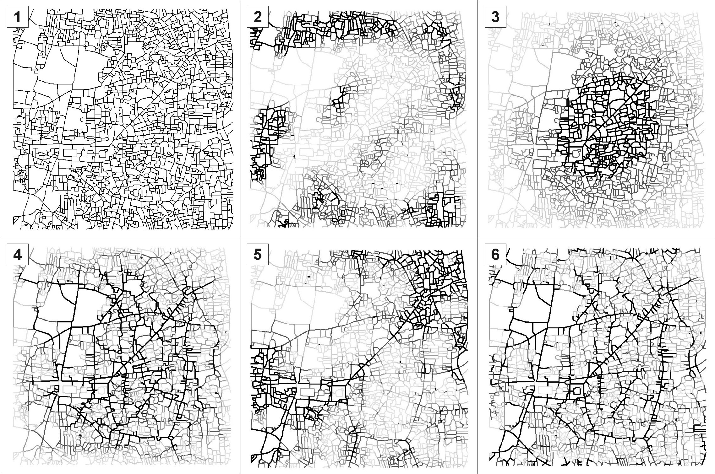

Fig.1 One square mile of central Ahmedabad (India): 1. the primal graph; 2. local closeness (C^{C}₄₀₀; d=400mt); 3. global closeness (C^{C}_{GLOB}); 4. global betweenness (C^{B}_{GLOB}); 5. global straightness (C^{S}_{GLOB}); 6. global information (C^{I}_{GLOB}).

Not all city’s structures are complex in the same way and to the same extent. Planned and self-organized cities look very different: the former exhibit a geometric flavour for their streets are very often regularly spaced and oriented so that we recognize shapes of Euclidean geometry like triangles, rectangles or pentagon, while in the latter, i.e. medieval urban fabrics grown gradually and “spontaneously” through history without any central control, we hardly recognize anything but a mess (fig.1, plate 1). But is that really a mess, a chaos, or it is just that we are not capable to see an order of a different kind? Other biological, social, technological, economic or cultural self-organized systems, virtually all other systems that have passed through and evolutionary process and as such are not the product of one single agent, have been found to exhibit some astonishingly similar properties. The basic of such shared property is a largely heterogeneous, “scale-free” distributions of centrality among the nodes: you have very few nodes that take high centrality and a lot of nodes that take quite a bit. We have shown that the same rule actually applies to organic, historical, self-organized urban patterns while it does not to planned ones. So, even if we do not see it at a first glance, historical patterns does have an order – though not one of an Euclidean kind: they actually exhibit the same order of most other organic systems in nature, an order that ensures extraordinary performances to such systems in terms of adaptability to external threats, capability to modify and react, diffuse information efficiently and strengthen local ties. The “small-world” property which emerges in self-organized systems as the capacity to achieve good performances both at the local and the global level, also is detectable at the highest grade in medieval urban patterns. Here, no matter if Arabic or European, rich or poor, hot or cold, Islamic or Christian, the urban structure ensures a cost comparable to that of a tree-like structure but with an efficiency comparable to that of a completed interconnected network. The same “small world” behaviour, though at a much lower grade, is present in grid-iron and mixed fabrics; conversely, modernist or suburban lollipop fabrics do not exhibit such property as they minimize the cost of the network generating on the other side a failure in the efficiency of the system as a whole (Cardillo et al, 2006).

6. Centrality and the location of community retail and services

Cities have grown in history following (to a certain extent) rules of centralities that are a factor of efficiency in making complex urban systems competitive in evolution. The idea is that we can actually see some clues of this in how several dynamics of particular relevance correlate on the ground to the spatial distribution of centrality. We have worked out a first test over the city of Bologna, northern Italy. Here, we correlate the centrality indices of closeness, betweenness and straightness, computed at the global and local levels, to dynamics inherent to daily urban life, i.e. the location of community-level commercial activities and services.

Rather than comparing centrality and commerce/service dynamics on a street-by-street basis (Hillier et al, 1993; Penn et al, 1998), we have explored in Bologna a different methodology based on the Kernel Density Evaluation (KDE), a density function based on Euclidean distance widely used in Geographic Information science and spatial analysis (Silverman, 1986; Holm T, 1997). This KDE-correlation methodology presents a double advantage: on one hand, it nicely captures the decreasing influence that centrality shows in the urban space, as the distance increases, from a given location (not only shops facing a street take advantage of that street’s centrality, but also those located nearby on the parallel streets, though at a lower level); on the other hand, it overcomes the problem of achieving fine cross-referenced data needed for a street-by-street correlation analysis.

In this study, after a preliminary MCA step, we “covered” the Bologna urban region with a grid of 2,771,956 square cells (edge=10m). We then calculated the Kernel Density of each cell of the study region in terms of all centrality indices (derived by MCA) and, on the other side, all commerce and service locations. Then we produced a table where, for each cell (record), Kernel density values of both kinds were associated. In tab.1 we report some structural data of cell values and the resulting Pearson index of linear correlation for each couple of considered variables. Such index expresses how much two quantities are correlated by giving a number between -1 (most negative correlation) and 1 (most positive); however, the value of the Pearson correlation decreases as the dataset size increases due to statistical fluctuations (Taylor, 1982). We choose to limit the dataset to cells containing at least one non zero value. Resulting Pearson values are positive for all couples of variables (tab.1) varying from 0.37 to 0.67; the index reaches the highest score – extremely significant for a dataset of such a magnitude – for global betweenness centrality. Such findings suggest that centrality, especially global betweenness, are driving forces for as crucial factors in the evolution of city life like the location of community shops and services, a correlation that also emerges through the simple visual comparison of spatial maps (fig.2).

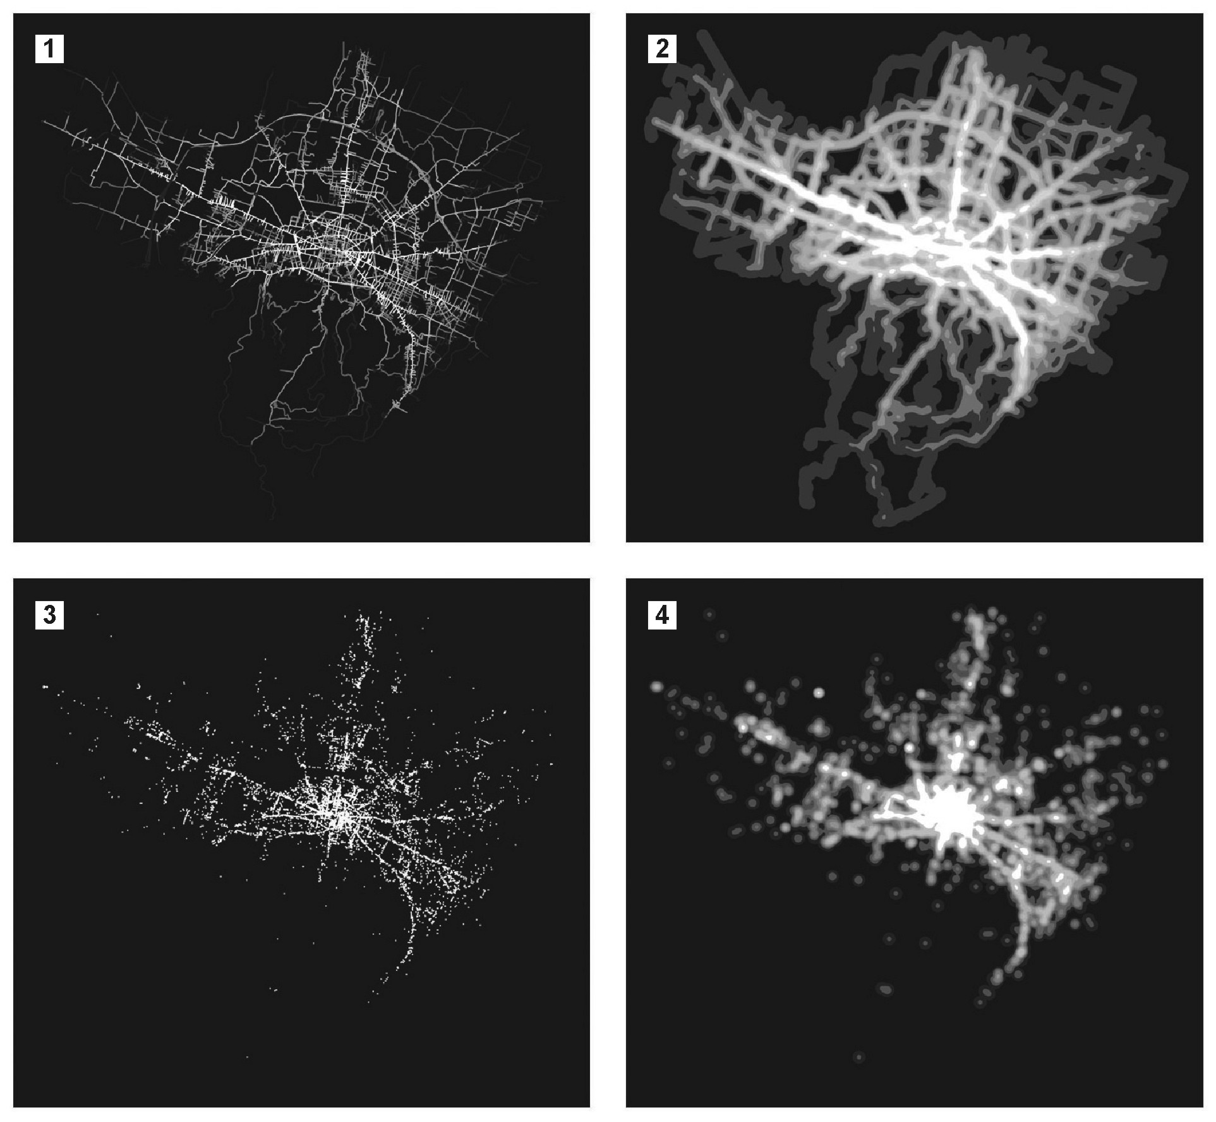

Fig.2 Bologna (northern Italy): Global Betweenness centrality on the primal graph of the road system, one outcome of the MCA application (1); Kernel Density Evaluation (bandwidth = 200 mt) of Global Betweenness (2); community commerce and service locations (3); Kernel Density Evaluation (bandwidth = 200 mt) of commerce and service locations (2). The linear correlation between density values of panels 2 and 4 reaches the highest score (Pearson=0,673) among those mentioned in Tab.1.

Correlated  Variables | 1  KDE Bandwith | 2  N00 | 3  NCD | 4  NC0 | 5  N0D | 6  Pearson  coefficient
C^{B}_{GLOB}/Comm+Serv | 200 | 54.7% | 22.7% | 22.3% | 0.323% | 0,673
C^{B}_{GLOB}/Comm | 200 | 54.9% | 18.4% | 26.6% | 0.158% | 0,653
C^{C}_{GLOB}/Comm+Serv | 200 | 54.7% | 22.7% | 22.3% | 0.323% | 0,583
C^{B}_{GLOB}/Comm+Serv | 100 | 66.3% | 13.3% | 19.9% | 0.550% | 0,567
C^{B}_{GLOB}/Comm | 100 | 66.6% | 10.3% | 22.8% | 0.239% | 0,555
C^{C}_{GLOB}/Comm | 200 | 54.9% | 18.4% | 26.6% | 0.158% | 0,547
C^{S}_{GLOB}/Comm+Serv | 200 | 55.0% | 22.7% | 22.3% | 0.323% | 0,546
C^{C}₈₀₀/Comm+Serv | 200 | 54.7% | 22.7% | 22.3% | 0.323% | 0,488
C^{C}₈₀₀/Comm | 200 | 54.9% | 18.4% | 26.6% | 0.158% | 0,460
C^{S}_{GLOB}/Comm+Serv | 100 | 66.3% | 13.3% | 19.9% | 0.550% | 0,392
C^{S}₈₀₀/Comm | 200 | 55.0% | 9.8% | 35.2% | 0.026% | 0,377
C^{S}_{GLOB}/Comm | 200 | 55.0% | 9.8% | 35.2% | 0.026% | 0,375

Tab.1 Bologna: correlation between centrality and community commerce/service locations. From left to right: variables of Centrality-Commerce/Service location dynamics; 1: extension of the bandwidth considered in KDE; 2: ratio of cells with both Centrality (C) and Dynamic (D)=0; 3: both C and D≠0; 4: C≠0 and D=0; 5: C=0 and D≠0; 6: Pearson index of linear correlation.

6. Conclusion: centrality and the design of cities

How can we understand where to locate shops and retail services in a proposed development? Where can we place the main hall in a company headquarter? What impacts can we expect from the realization of a new bridge or road on the rest of a city system? How can we better integrate a neighbourhood (like a social housing estate) in its immediate and global surroundings? These are all crucial questions in sustainable urban design processes and centrality, it turns out, is a driving force in all this. MCA, as a tool for managing centrality in real spatial systems at all scales can help decision makers directly and efficiently with a scientific-based assistance in processes of architectural and urban design. The same approach is being also experimented in more specific areas of transport planning and management: how can we improve the performance of a public transport system by adding just a certain amount of new lines or stops? Is a proposed transport system extension plan actually going to give the right answers to one community’s needs? The application of MCA to “classic” transport planning issues is one of the main directions of development for our current research (Scheurer and Porta, 2006).

Acknowledgements: Our thanks for the Bologna study to: Salvo Scellato and Alessio Cardillo (computation of centrality and correlation values), Valentino Iacoviello and Emanuele Strano (GIS dataset management and spatial analysis), Roberto Messora (GIS dedicated software development). Data were kindly provided, on behalf of the Municipality of Bologna, by dr. Andrea Minghetti, dr. Giovanni Fini and dr. Gabriella Santoro.

References

Cardillo A, Scellato S, Latora V, Porta S (2006), Structural properties of planar graphs of urban street patterns, Physical Review E, Journal of the American Physical Society, 73 6,
Crucitti P, Latora V, Porta S (2006a), Centrality measures in spatial networks of urban streets, Physical Review E, Journal of the American Physical Society, 73 3.

Crucitti P, Latora V, Porta S. (2006b), Centrality in networks of urban streets, Chaos, Quarterly of the American Institute of Physics, 16 1.

Hillier B, Penn A, Hanson J, Grajewski T, Xu. J (1993), Natural movement; or, configuration and attraction in urban space use, Environment and Planning B: Planning and Design, 20 1.

Holm T (1997), Using GIS in Mobility and Accessibility Analysis, ESRI Users Conference, San Diego, http://www.esri.com/library/userconf/proc97/proc97/to450/pap440/p440.htm.

Penn A, Hillier B, Banister D, Xu J (1998), Configurational modelling of urban movement networks, Environment and Planning B: Planning and Design, 25 1.

Penn A (2003), Space Syntax And Spatial Cognition: Or Why the Axial Line?, Environment and Behavior, 35 1.

Porta S, Crucitti P, Latora V (2006a), The network analysis of urban streets: a dual approach, Physica A, Statistical mechanics and its applications, 369 2.

Porta S, Crucitti P, Latora V. (2006b), The network analysis of urban streets: a primal approach, Environment and Planning B: planning and design, 33 5.

Scheurer J, Porta S (2006), Centrality and Connectivity in Public Transport Networks and their Significance for Transport Sustainability in Cities, paper presented at the World Planning Schools Congress, Mexico DF, 13-16 July 2006.

Scellato S, Cardillo A, Latora V, Porta S (2006), The Backbone of a city, The European Physical Journal B, 50 1-2.

Silverman BW (1986), Density Estimation for Statistics and Data Analysis, Chapman and Hall, London.

Taylor JR (1982), An Introduction to Error Analysis, The Study of Uncertainties in Physical Measurements, University Science Books, Mill Valley, CA.

Wilson GA (2000), Complex spatial systems: the modelling foundations of urban and regional analysis, Prentice Hall, Upper Saddle River, NJ.

